AUCKLAND CRICKET ASSOCIATION TITLES, CUPS, & PENNANTS

## This recognises the teams that have won A.C.A. grade titles, cups, and pennants*.

Grade titles in red are the premier A.C.A. titles.

Junior Pennants not awarded since 2018-19 Season

Updated 23 May 2024

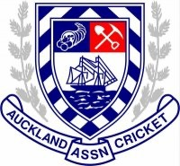

2023-24 SEASON (2)

MENS PREMIER RESERVE TWO DAY MINOR CHAMPIONSHIP

MENS ONE DAY 3A GRADE MAJOR (FLAMING BALLS OF FURY)

2022-23 SEASON (3)

MENS PREMIER RESERVE T20 CHAMPIONSHIP

MENS ONE DAY 2A GRADE MAJOR (AVENGERS)

MENS ONE DAY 3B GRADE MAJOR (FLAMING BALLS OF FURY)

2021-22 SEASON (4)

WOMEN’S PREMIER GRADE TWENTY20 CHAMPIONSHIP  
MENS PREMIER RESERVE LIMITED OVERS MINOR CHAMPIONSHIP  
MENS ONE DAY 2B GRADE MAJOR (AVENGERS)  
GIRLS U13 HARDBALL GRADE WINNERS (HUDDLESTON)

2020-21 SEASON (5)

MENS ONE DAY 2B GRADE MINOR CHAMPIONSHIP (AVENGERS)   
MENS ONE DAY 3B GRADE MINOR CHAMPIONSHIP (RANGERS)

MENS ONE DAY 4A GRADE MINOR CHAMPIONSHIP (FLAMING BALLS OF FURY)  
SUNDAY T20 COMPETITION 2019 - 1A – POST (SUPER GIANTS)  
MEN’S UNDER 23 CHAMPIONSHIP

# 2019-20 SEASON (8) WOMEN'S PREMIER GRADE - PEARL DAWSON - TWENTY20 CHAMPIONSHIP 2019/20 MENS ONE DAY 4A GRADE CHAMPIONSHIP (FLAMING BALLS OF FURY)

BOYS COO UNDER 13 (A)

POST XMAS

BOYS MIDWEEK U16 HALF SEASON (AUCC) BOYS MIDWEEK U13 HALF SEASON (HURRICANES)  
  
PRE XMAS

BOYS MIDWEEK U16 HALF SEASON (BLUE) BOYS MIDWEEK U13 HALF SEASON (BLUE)

BOYS MIDWEEK U12 HALF SEASON (HURRICANES)

# 2018-19 SEASON (14) WOMEN'S PREMIER GRADE - PEARL DAWSON - TWENTY20 CHAMPIONSHIP (UNI/WAITAK) PRESIDENTS SOCIETY BOWL CHAMPIONSHIP

BOYS PINK SATURDAY LO Y7 (HURRICANES)

POST XMAS

SUNDAY T20 COMPETITION 2019 - 1A – POST (SUPER GIANTS) MENS ONE DAY 2B GRADE CHAMPIONSHIP (KASHMIR XI)

MENS ONE DAY 4A GRADE CHAMPIONSHIP (FLAMING BALLS OF FURY) COLLEGE SPORT COLTS 9'S LO (AUCC)

GIRLS WHITE SAT T20 U11 (HUDDLESTON)

PRE XMAS

MEN’S 1 DAY 2C (KASHMIR XI) MEN'S 1-DAY 3A (AVENGERS)

BOYS MIDWEEK Y7 HALF SEASON WHITE SOUTH EAST (RED) BOYS MIDWEEK Y8 HALF SEASON EAST A GRADE (ASTEROIDS) BOYS MIDWEEK Y8 HALF SEASON EAST B GRADE (SUPER NOVAS) GIRLS WHITE SAT T20 U11 (PETERSON)

***Junior Pennants not awarded since 2018-19 Season***

# 2017-18 SEASON (6)

WOMEN’S PREMIER AUCC/WAITAKERE PRICHARD CUP LIMITED-OVERS CHAMPIONSHIP WOMEN’S PREMIER AUCC/WAITAKERE PEARL DAWSON TROPHY T20 CHAMPIONSHIP MEN’S SUNDAY T20 1B PRE-XMAS CHAMPIONSHIP (WARRIORS)

MEN’S SUNDAY T20 2A POST-XMAS CHAMPIONSHIP (VARSITY VIKINGS) YEAR 9/10 - JUNIOR OPEN B PRE-XMAS CHAMPIONSHIP (BARBARIANS) YEAR 8 **-** YEAR 8A PRE-XMAS POOL 2 CHAMPIONSHIP (PLANETS)

# 2016-17 SEASON (6)

WOMEN’S PREMIER T20 CHAMPIONSHIP

MEN’S 1-DAY 3A CHAMPIONSHIP (KASHMIR XI)

MEN’S 1-DAY 3B CHAMPIONSHIP (RANGERS)

MINI HEARTS U10 2017 CHAMPIONSHIP (CPS DEMONS) MINI HEARTS U10 2016 CHAMPIONSHIP (CPS DEMONS) YEAR 7 PREMIER SHIELD (HURRICANES)

# 2015-16 SEASON (5)

MEN’S PREMIER RESERVE 2-DAY MINOR CHAMPIONSHIP MEN’S SUNDAY T20 1A 2015 CHAMPIONSHIP (SUPER SIXES) MEN’S SUNDAY T20 1B 2016 CHAMPIONSHIP (YOUNG SPORTS) JUNIOR HEARTS U12B CHAMPIONSHIP (HIT N RUNNERS) YEAR 6A BOWL CHAMPIONSHIP (CHARGERS)

# 2014-15 SEASON (9)

MEN’S PREMIER T20 PLATE CHAMPIONSHIP MEN’S 2-DAY A1 OVERALL CHAMPIONSHIP MEN’S 2-DAY A1 2-DAY CHAMPIONSHIP

MEN’S 1-DAY 4C CHAMPIONSHIP (FLAMING BALLS OF FURY) MEN’S SUNDAY T20 1A 2015 CHAMPIONSHIP (SUPER SIXERS) MEN’S SUNDAY T20 1B 2014 CHAMPIONSHIP (SUPER SIXERS) YEAR 9-10A T20 BLACK SECTION CHAMPIONSHIP (AZTECS) YEAR 8 PREMIER 2-DAY 2015 CHAMPIONSHIP (ASTERIODS) YEAR 6 PREMIER MINOR CHAMPIONSHIP (BRONCOS)

# 2013-14 SEASON (12)

MEN’S PREMIER 2-DAY MINOR CHAMPIONSHIP – TOM HELLABY TROPHY MEN’S SUNDAY T20 2A PRE-XMAS CHAMPIONSHIP (MOTHRIDERS) MEN’S SUNDAY T20 2B POST-XMAS CHAMPIONSHIP (SLUGGERS)

MINI HEARTS U10 MELVILLE MODULE (GURREY) YEAR 9-10 A 2-DAY MAJOR CHAMPIONSHIP (PIRATES)

YEAR 9-10 A TWENTY20 BLACK CHAMPIONSHIP (CAVALIERS) YEAR 8 PREMIER ONE DAY WHITE CHAMPIONSHIP (COMETS) YEAR 8A MINOR CHAMPIONSHIP (STARS)

YEAR 7A MAJOR CHAMPIONSHIP (STORM)

YEAR 6 PREMIER MAJOR CHAMPIONSHIP (MUSTANGS)

YEAR 6A MAJOR CHAMPIONSHIP (BRUMBIES) YEAR 6B MINOR CHAMPIONSHIP (SPURS)

# 2012-13 SEASON (10)

MEN’S PREMIER RESERVE 2-DAY CHAMPIONSHIP MEN’S 2-DAY A1 2-DAY CHAMPIONSHIP

MEN’S 1-DAY 4B CHAMPIONSHIP (IRON MAIDEN) MEN’S SUNDAY T20 1B CHAMPIONSHOP (MOTHRIDERS)

MEN’S SUNDAY T20 2A CHAMPIONSHOP (RUSSEL BRICKLAYERS) YEAR 9-10 A GRADE TWO DAY MAJOR CHAMPIONSHIP

YEAR 7B CHAMPIONSHIP

YEAR 6 PREMIER PLATE CHAMPIONSHIP (BRUMBIES) YEAR 6B CHAMPIONSHIP (COLTS)

MINI HEARTS U10 GRADE MELVILLE MODULE (BROADMORE)

# 2011-12 SEASON (6)

MEN’S 2-DAY B1 OVERALL CHAMPIONSHIP MEN’S 2-DAY B1 2-DAY CHAMPIONSHIP MEN’S 2-DAY B1 1-DAY CHAMPIONSHIP

YEAR 7 A MAJOR CHAMPIONSHIP (HURRICANES) YEAR 7B CHAMPIONSHIP (THUNDER)

YEAR 6B CHAMPIONSHIP (MUSTANGS)

# 2010-11 SEASON (6)

GROSVENOR CUP

WOMEN’S PREMIER RESERVE T20 CHAMPIONSHIP MEN’S 1-DAY 6A CHAMPIONSHIP (BALLS OF FURY) MEN’S SUNDAY T20 2A CHAMPIONSHIP (BYRNES XI)

YEAR 9-10A GRADE 2-DAY MAJOR CHAMPIONSHIP (CAVALIERS) YEAR 7 PREMIER GRADE MINOR CHAMPIONSHIP (HURRICANES)

# 2009-10 SEASON (11)

MEN’S 2-DAY C1 MAJOR CHAMPIONSHIP MEN’S 1-DAY 4A CHAMPIONSHIP (THE GREENS) MEN’S 1-DAY 4C CHAMPIONSHIP (IRON MAIDEN)

MEN’S SUNDAY T20 1B CHAMPIONSHIP (TOTAL BEIGE AUTHORITY)

MEN’S SUNDAY T20 2A CHAMPIONSHIP (OGILVIE) MEN’S SUNDAY T20 2B PLATE (STRAGGLERS)

JUNIOR HEARTS U12 SOFTBALL CHAMPIONSHIP (DRUMM) YEAR 8A GRADE MAJOR CHAMPIONSHIP (ASTEROIDS) YEAR 8B GRADE CHAMPIONSHIP (COMETS)

YEAR 7 PREMIER GRADE MINOR CHAMPIONSHIP (HURRICANES) YEAR 7A GRADE MAJOR CHAMPIONSHIP (TYPHOON)

# 2008-09 SEASON (8)

MEN’S PREMIER RESERVE 2-DAY MAJOR CHAMPIONSHIP MEN’S PREMIER RESERVE T20 CHAMPIONSHIP

MEN’S 2-DAY C1 MINOR CHAMPIONSHIP

U15 PREMIER 2 GRADE 1-DAY CHAMPIONSHIP (MAVERICKS) U15 A GRADE 1-DAY CHAMPIONSHIP (MAVERICKS)

YEAR 8A CHAMPIONS YEAR 8B CHAMPIONSHIP

YEAR 6 PREMIER MAJOR CHAMPIONS (COLTS)

# 2007-08 SEASON (1)

MEN’S PREMIER RESERVE 2-DAY MAJOR CHAMPIONSHIP

# 2006-07 SEASON (1)

JUNIOR HEARTS U12 SOFTBALL

# 2005-06 SEASON (1)

U15 PREMIER 1 GRADE 1-DAY CHAMPIONSHIP

# 2003-04 SEASON (1)

MEN’S THIRD GRADE CHAMPIONSHIP

# 2002-03 SEASON (2)

MEN’S FIRST GRADE 2-DAY CHAMPIONSHIP U15 PREMIER 2 GRADE 1-DAY CHAMPIONSHIP

# 2001-02 SEASON (4)

MEN’S FIRST GRADE LIMITED OVERS RUNNER-UP MEN’S 1-DAY 3B CHAMPIONSHIP

U14 GRADE 2002 CHAMPIONSHIP U14 GRADE 2001 CHAMPIONSHIP

# 2000-01 SEASON (3)

MEN’S 1-DAY 1A CHAMPIONSHIP MEN’S 1-DAY 6A PLATE

U15 B1 GRADE CHAMPIONSHIP

# 1999-00 SEASON (2)

WOMEN’S FIRST GRADE MOST IMPROVED TEAM WOMEN’S MOST TEAM CATCHES  
  
1998-99 SEASON (5)

WOMENS FIRST GRADE 1-DAY RUNNER-UP MEN’S 1-DAY 4 PLATE

MEN’S 1-DAY 6 PLATE MEN’S 1 DAY 7 PLATE U17A PLATE

# 1997-98 SEASON (5)

MEN’S SECOND GRADE PLATE

MEN’S 1-DAY 1 CHAMPIONSHIP (THE LAUGHING TROUTS) MEN’S 1-DAY 2 CHAMPIONSHIP (CEYLON)

MEN’S 1-DAY 5 CHAMPIONSHIP MEN’S 1-DAY 6 PLATE

# 1996-97 SEASON (5)

MEN’S FIRST GRADE CHAMPIONSHIP RUNNER-UP MEN’S 1-DAY 3 CHAMPIONSHIP (CEYLON)

MEN’S 1-DAY 9 PLATE

U17 SECOND GRADE CHAMPIONSHIP U15 THIRD GRADE DIVISION 2

# 1994-95 SEASON (3)

MEN’S 1-DAY 2 CHAMPIONSHIP MEN’S 1-DAY 3 CHAMPIONSHIP U16 REGIONAL A CHAMPIONSHIP

# 1993-94 SEASON (5)

WOMEN’S ASB OVERALL CHAMPIONSHIP MEN’S 1-DAY 4 CHAMPIONSHIP MEN’S 1-DAY 5 CHAMPIONSHIP

MEN’S 1-DAY 6(DIV 2) CHAMPIONSHIP U14 REGIONAL B GRADE WINNERS

# 1992-93 SEASON (2)

MEN’S 1-DAY 2 CHAMPIONSHIP MEN’S 1-DAY 8 CHAMPIONSHIP

# 1991-92 SEASON (1)

COLTS TOURNAMENT

# 1990-91 SEASON (1)

PRESIDENTS GRADE OVERAL CHAMPIONSHIP

# 1989-90 SEASON (2)

MEN’S SENIOR C4 CHAMPIONSHIP MEN’S 1-DAY 2 CHAMPIONSHIP

# 1987-88 SEASON (1)

PRESIDENTS GRADE CHAMPIONSHIP

# 1986-87 SEASON (2)

MEN’S SENIOR B CHAMPIONSHIP MEN’S 1-DAY 6 CHAMPIONSHIP

# 1985-86 SEASON (2)

PRESIDENTS GRADE CHAMPIONSHIP U16 SUBSIDIARY SECTION B CHAMPIONSHIP

# 1984-85 SEASON (5)

MEN’S 1-DAY 2 1st ROUND WINNERS (UNI INDIANS) MEN’S 1-DAY 3 1st ROUND WINNERS

U18 PREMIER 1st ROUND WINNERS U16 C CHAMPIONSHIP COLTS TOURNAMENT

# 1983-84 SEASON (3)

MEN’S SENIOR A 1ST ROUND WINNERS U17 REGIONAL CHAMPIONSHIP (BLUE) U15 SUBSIDIARY A CHAMPIONSHIP (BLUE)

# 1982-83 SEASON (3)

MEN’S SENIOR A CHAMPIONSHIP MEN’S SENIOR A 1st ROUND WINNERS U17 – SUBSIDIARY CHAMPIONSHIP

# 1980-81 SEASON (1)

MEN’S SENIOR A 1st ROUND WINNERS

# 1979-80 SEASON (5)

MEN’S SENIOR B 1ST ROUND WINNERS MEN’S 1-DAY A 1ST ROUND WINNERS PRESIDENTS GRADE 1ST ROUND WINNERS

MEN’S PREMIER 1-DAY RED SECTION WINNERS HEC SUTHERLAND MEMORIAL ROSEBOWL

# 1978-79 SEASON (3)

MEN’S SENIOR A 1ST ROUND WINNERS INTERMEDIATE B GRADE 1ST ROUND WINNERS HEC SUTHERLAND MEMORIAL ROSEBOWL

# 1977-78 SEASON (7)

MEN’S SENIOR A1 CHAMPIONSHIP MEN’S SENIOR FIRST B CHAMPIONSHIP

MEN’S SENIOR B2 CHAMPIONSHIP (ST HELIERS) MEN’S SENIOR SECOND A 1ST ROUND WINNERS MEN’S OPEN B GRADE 1ST ROUND WINNERS MEN’S INTERMEDIATE C GRADE CHAMPIONSHIP

MEN’S FOURTH A GRADE 1ST ROUND WINNERS (ST HELIERS)

# 1976-77 SEASON (2)

MEN’S SENIOR FIRST B GRADE 2ND ROUND CHAMPIONSHIP (ST HELIERS) MEN’S SENIOR FOURTH B GRADE 2ND ROUND CHAMPIONSHIP (ST HELIERS)

# 1975-76 SEASON (3)

MEN’S SENIOR GRADE CHAMPIONSHIP ACA CLUB CHAMPIONSHIP WINNERS

JUNIOR GRADE CHAMPIONSHIP (ST HELIERS)

# 1974-75 SEASON (4)

MEN’S SENIOR GRADE CHAMPIONSHIP MEN’S SENIOR B1 2ND ROUND CHAMPIONSHIP

GROSVENOR CUP

HEC SUTHERLAND MEMORIAL ROSEBOWL

# 1973-74 SEASON (1)

JUNIOR GRADE CHAMPIONSHIP (ST HELIERS)

# 1972-73 SEASON (2)

HEC SUTHERLAND MEMORIAL ROSEBOWL MEN’S SENIOR RUNNERS-UP

# 1970-71 SEASON (3)

MEN’S SENIOR B CHAMPIONSHIP MEN’S SENIOR THIRD GRADE (ST HELIERS)

MEN’S SENIOR FOURTH GRADE FIRST DIVISION 1ST ROUND WINNERS

# 1966-67 SEASON (2)

MEN’S SENIOR THIRD GRADE CHAMPIONSHIP JUNIOR GRADE CHAMPIONSHIP (ST HELIERS)

# 1960-61 SEASON (2)

MEN’S FIRST GRADE CHAMPIONSHIP

MEN’S SENIOR SECOND GRADE SUBSIDIARY CHAMPIONSHIP

# 1955-56 SEASON (1)

MEN’S FIRST GRADE SUBSIDIARY CHAMPIONSHIP

# 1954-55 SEASON (1)

MEN’S SECOND GRADE SUBSIDIARY CHAMPIONSHIP

# 1953-54 SEASON (1)

MEN’S SECOND GRADE SUBSIDIARY CHAMPIONSHIP

# 1946-47 SEASON (1)

GROSVENOR CUP

# 1940-41 SEASON (2)

MEN’S FIRST GRADE CHAMPIONSHIP GROSVENOR CUP

# 1939-40 SEASON (1)

MEN’S SENIOR B CHAMPIONSHIP

# 1930-31 SEASON (1)

MEN’S THIRD GRADE B SECTION CHAMPIONSHIP

# 1926-27 SEASON (1)

MEN’S SECOND GRADE CHAMPIONSHIP (AKARANA)

# 1924-25 SEASON (1)

MEN’S FIRST GRADE CHAMPIONSHIP

# 1920-21 SEASON (1)

MEN’S FIRST GRADE CHAMPIONSHIP

## *This document was compiled in 2012 by Daniel Marsic and the Fisher family using archived A.C.A. annual reports (missing reports: 1999-00, 2000-01& Excludes Middlemore Cricket Club titles).

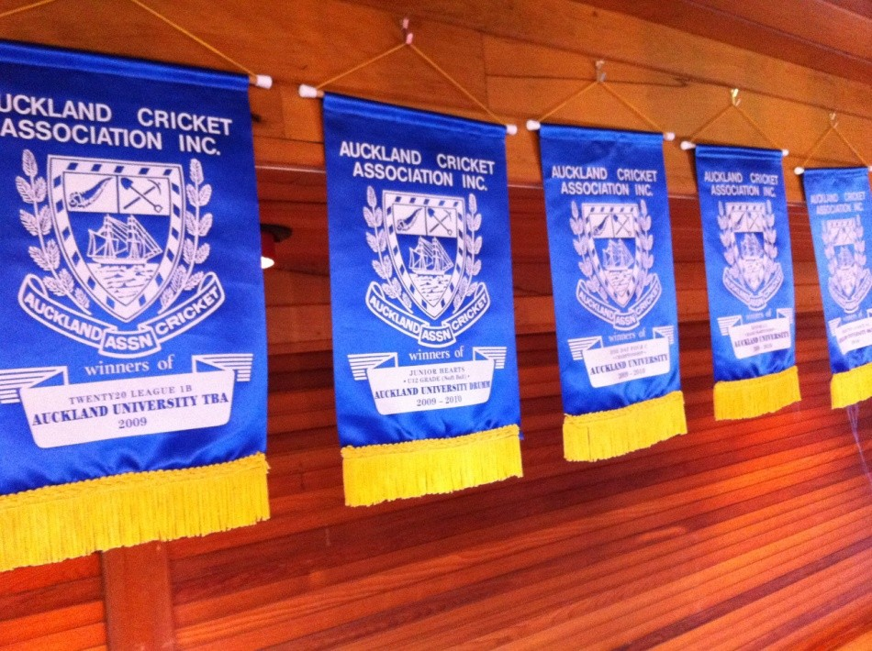

**A.C.A. Pennants**